[Ruthu Rao](mailto:ruthurao@gmail.com)

//To create a directory

hadoop fs -mkdir /route2

//to list the files and directory

hadoop fs -ls /

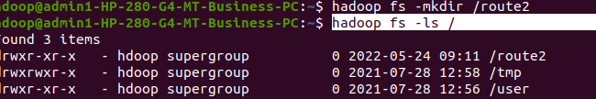

//to create 2 files locally

hdfs dfs -touchz /route2/file1.txt

hdfs dfs -touchz /route2/file2.txt

hadoop fs -ls /route2

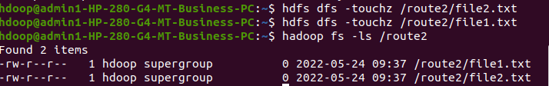

//insert files locally

hdfs dfs -mkdir /1NT19IS133

hdfs dfs -put /home/hdoop/Desktop/1NT19IS133/

hdfs dfs -put /home/hdoop/Desktop/ruthu133 /1NT19IS133

hadoop fs -ls /1NT19IS133

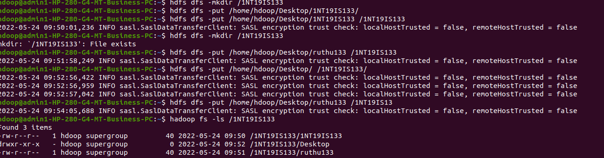

//getting from hadoop

hdfs dfs -get /1NT19IS133 /ruthu133 /home/hdoop/Desktop

//move to local

hdfs dfs -get /1NT19IS133/ruthu133 /home/hdoop/Desktop



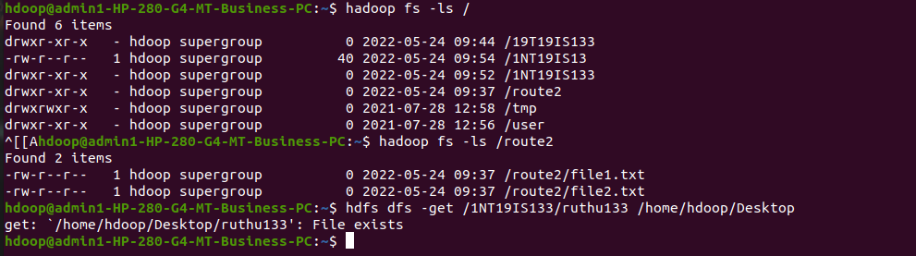

//cp command

hadoop fs -cp /1NT19IS133/ruthu133 /route2

2022-05-24 10:42:27,767 INFO sasl.SaslDataTransferClient: SASL encryption trust check: localHostTrusted = false, remoteHostTrusted = false

2022-05-24 10:42:27,846 INFO sasl.SaslDataTransferClient: SASL encryption trust check: localHostTrusted = false, remoteHostTrusted = false

hdoop@admin1-HP-280-G4-MT-Business-PC:~$ hadoop fs -ls /route2

Found 3 items

-rw-r--r-- 1 hdoop supergroup 0 2022-05-24 09:37 /route2/file1.txt

-rw-r--r-- 1 hdoop supergroup 0 2022-05-24 09:37 /route2/file2.txt

-rw-r--r-- 1 hdoop supergroup 40 2022-05-24 10:42 /route2/ruthu133

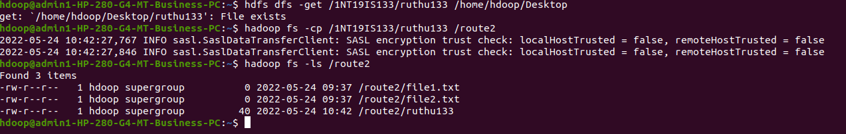

//du size of the directory

hdoop@admin1-HP-280-G4-MT-Business-PC:~$ hdfs dfs -du -h /1NT19IS133

40 40 /1NT19IS133/1NT19IS133

21.0 K 21.0 K /1NT19IS133/Desktop

40 40 /1NT19IS133/ruthu133

hdoop@admin1-HP-280-G4-MT-Business-PC:~$ hdfs dfs -du -h /route2

0 0 /route2/file1.txt

0 0 /route2/file2.txt

40 40 /route2/ruthu133



//cat command